**Digital Mechanic Web and Mobile Based Application**

By

Masood Ur Rehman (CS120192033, [Masoodurrehman1235@gmail.com](mailto:Masoodurrehman1235@gmail.com))

**Supervisor**

Abdur Rehman

Institute of Computing

KUST, Kohat

__________________

Signature



**Institute of Computing**

**Kohat University of Science and Technology, Kohat-26000**

**Khyber Pakhtunkhwa, Pakistan**

**Digital Mechanic Web and Mobile Based Application**

Masood Ur Rehman (CS120192033)

A thesis submitted in partial fulfillment of the requirements for the degree of

BSCS.

Thesis Supervisor:

Abdur Rehman

Thesis Supervisor’s Signature: ____________________________________

FYP Coordinator’s Signature: ____________________________________

## Director’s Signature: ____________________________________

**Institute of Computing**

**Kohat University of Science and Technology, Kohat-26000**

**Khyber Pakhtunkhwa, Pakistan**

**Table of Contents**

**Declaration ..................................................................................................................................................................**

**Plagiarism Certificate (Turnitin Report) .................................................................................................................**

**Acknowledgements .....................................................................................................................................................**

**Dedication ....................................................................................................................................................................**

**Abstract ....................................................................................................................................................................**

**List of Figures .............................................................................................................................................................**

**List of Tables ...............................................................................................................................................................**

**CHAPTER 1: INTRODUCTION.............................................................................................................................**

**1.1: Introduction ....................................................................................................................................................**

**1.2: Existing work ..................................................................................................................................................**

**1.3: Problem Statement**-----------------------------------------------------------------------------------------------------

**1.4: Proposed Solution.............................................................................................................................................**

**1.5: Motivation ........................................................................................................................................................**

**1: Objectives----------------------------------------------------------------------------------------------------------**

**2: Tools and Technologies-----------------------------------------------------------------------------------------**

**3: Work plan---------------------------------------------------------------------------------------------------------**

**4: Explanation-------------------------------------------------------------------------------------------------------**

**CHAPTER 2: REQUIREMENT AND PROPOSED SYSTEM ............................................................................**

**2.1: Module Wise Requirement Anaylsis........................................................................................................**

**1. User Management Module**---------------------------------------------------------------------------------------

**2. Product Management Module**-----------------------------------------------------------------------------------

**3. Blog Management Module**----------------------------------------------------------------------------------------

**4. Order Management Module**--------------------------------------------------------------------------------------

**5. Booking Management Module**-----------------------------------------------------------------------------------

**6. Admin Management Module**-------------------------------------------------------------------------------------

**7. Mechanic Service Management Module**------------------------------------------------------------------------

**2.2: Requirement Gathering....................................................................................................................**

**2.3: Functional Requirements..................................................................................................................**

**2.4: Non-Functional Requirements..........................................................................................................**

**CHAPTER 3: DESIGN AND ANALUSIS ..............................................................................................................**

**3.1: introduction ............................................................................................................................................**

**3.2: use case diagram .......................................................................................................................**

**3.3: data flow diagram .................................................................................................................**

**3.4: activity diagram ................................................................................................................**

**3.5: Sequence diagram ................................................................................................................**

**3.6: Architecture diagram ................................................................................................................**

**3.7: Entity Relationship Diagram (ERD).............................................................................................................**

**CHAPTER 4: IMPLEMENTATION ......................................................................................................................**

**4.1: system implementation ..................................................................................................................................**

**4.2: selection of language ...................................................................................................................................... CHAPTER 5: TESTING, INTEGRATION AND EVALUATION.......................................................................**

**5.1: system testing ..................................................................................................................................................**

**5.2: acceptance testing ...........................................................................................................................................**

**5.3: unit testing, signup page for users...............................................................................................................**

**5.4: unit testing, home page for users ..................................................................................................................**

**5.5: unit testing, orders page for users ................................................................................................................**

**5.6: unit testing, shop page for users ...................................................................................................................**

**5.7: unit testing, cart page for users.............................................................................................................**

**5.8: unit testing, services page for users .................................................................................................................**

**5.9: unit testing, bookings page for users .....................................................................................................**

**5.10: unit testing, blog page for users .....................................................................................................**

**5.11: unit testing, orders page for admin.....................................................................................................**

**5.12: unit testing, bookings page for admin .....................................................................................................**

**5.13: unit testing, blog page for admin .....................................................................................................**

**5.14: unit testing, users page for admin .....................................................................................................**

**CHAPTER 6: CONCLUSION AND FUTURE WORK ........................................................................................**

**6.1: conclusion ........................................................................................................................................................**

**6.2: future work .....................................................................................................................................................**

**REFERENCES ..........................................................................................................................................................**

**PLAGIARISM REPORT BY TURNITIN ..............................................................................................................**

**Declaration**

I hereby affirm that the project titled "Digital Mechanic Web and Mobile Based Application" is my original work. This project has not been submitted elsewhere for evaluation. I have duly acknowledged and referenced any materials that have been utilized in this work.

Signature of Student

**Plagiarism Certificate (Turnitin Report)**

This thesis has been checked for Plagiarism. Turnitin report endorsed by Supervisor is attached at the end of thesis.

______________________________________

Signature of Student

______________________________________

Signature of Supervisor

**Acknowledgements**

With the guidance and mercy of Allah Almighty I was able to successfully complete this thesis with the aspiration of a promising future. With the kind appreciation to my supervisor, Sir Abdur Rehman, whose kind and professional guidance played a significant role in the efficient and effective completion of my project. I am also thankful to my colleagues who constantly motivated and supported me, ensuring that I remained dedicated throughout the project's execution.

**Dedication**

I would like to dedicate my final year project to my beloved parents, who have provided extra ordinary support, love, and encouragement throughout my academic journey. Additionally, I would like to thanks, Sir Abdur Rehman, for his valuable guidance and mentorship throughout this journey.

**Abstract**

In Pakistan the total number of motor vehicles (including motorcycles, motor cabs/taxis, buses, trucks, cars, jeeps etc.) registered in 2020 were 29,964,594 [1]. Although, as we know that, there are a lot of mechanic shops that are physically available in our country and worldwide. But in most of the cases they are distant from people reach especially when their vehicle stops suddenly and got some issues while travelling, and also when people face issues at home regarding home appliances and purchasing the body parts of their vehicles etc. And the worst thing about is that there is not a single online platform exists that solves all these problems. This is very a big issue for every person which results in a lot time consumption and cost. So, with the help of a visual platform, you can easily place an order for purchasing a specific body part of your vehicle or booking an expert mechanic at the specific location. In this way not only, the problem of many people will be solved. But also, the opportunities of jobs will be increased. And according to estimated research there are 4 billion mobile phone users all around the world [2] and the statistics show that 88 percent of them research online before buying locally [2]. So, looking at all these things I decided to develop mobile and web-based application for taking the entire mechanical business to online. Digital Mechanic is a Web and Mobile based Platform that has aim to provide remarkable mechanic services including expert mechanics for cars and motorcycles to home appliances at the convenience of your door step. We are going to use all those features that will help people in everyday of their life routine from booking of expert mechanics and technicians to selling of related tools and equipment’s. The primary objective of the application is to provide a platform where users can conveniently access and purchase tools and equipment, as well as hire mechanic services. The application also features a blog section where users can access relevant articles and information. The digital mechanic application is designed to streamline the process of acquiring tools and equipment, making it easier for individuals to find and purchase the items they require. Additionally, the platform offers a seamless mechanism for users to hire professional mechanic services, addressing their automotive repair and maintenance needs.

**List of Figures**

**Fig 1**: Activity diagram for project ...............................................................................................

**Fig 2**: Activity diagram for admin ................................................................................................

**Fig 3**: Activity diagram for user ...................................................................................................

**Fig 4**: use case diagram for project .............................................................................................

**Fig 5**: use case diagram for admin ..............................................................................................

**Fig 6**: use case diagram for user .................................................................................................

**Fig 7**: class diagram for project ...................................................................................................

**Fig 8**: ERD diagram for project ....................................................................................................

**List of Tables**

**Table 1:** Unit Testing: Sign up as Admin ................................................................................................................

**Table 2:** Unit Testing: Sign up as User ...................................................................................................................

**Table 3:** Unit Testing: Sign in as Admin .................................................................................................................

**Table 4:** Unit Testing: Sign in as User ....................................................................................................................

**Table 5:** Unit Testing: Home screen for Admin .....................................................................................................

**Table 6:** Unit Testing: Home Screen for User ........................................................................................................

**CHAPTER 1: INTRODUCTION**

**1.1 Introduction: -**

Digital Mechanic is a Web and Mobile based Platform that has aim to provide remarkable mechanic services including expert mechanics for cars and motorcycles to home appliances at the convenience of your door step. We are going to use all those features that will help people in everyday of their life routine from booking of expert mechanics and technicians to selling of related tools and equipment’s.

And for this I have searched internet about this type of Application which can provide mechanical services that can fix most of people’s issues. But unfortunately, I haven’t found a single one that covers all these features. So, I decided to develop web and mobile based application which provide mechanical services from booking of an expert mechanic/technician to buying of related tools and equipment’s. And now if we look at the **background** of the problem then we have the following application that tries somehow to solve this issue but are not yet succeeded.

* 1. **Existing Work: -**
* **Mechanic USTAAD**
  1. **History**
     + Mechanic USTAAD is a website that provide services for booking of mechanics for cars, bikes and generators.
  2. **How it works**
     + User will have to visit their website, then a user can book a mechanic for repairing their cars, motorcycles or generators.
  3. **Issues**
     + There is no proper user interface designed.
     + User can only book a mechanic but there is no proper way to register a new mechanic in their platform.
     + There is no way to purchase tools and equipment’s.
     + There is no proper way of tracking and managing the order and bookings. Also, they don’t have mobile app.
     + Users can book a mechanic using a call or email.
     + Users are not facilitated for which it is created.
* **Careem** 
  1. **History**
     + Careem is a very famous website that provides services for riding, ordering and driving.
  2. **How it works**
     + User will have to visit their website, then a user can ride, become a caption(driver) and order food.
  3. **Issues**
     + Users cannot book a mechanic to repair their vehicles.
     + Users cannot purchase tools and equipment’s.
     + There is no blog to aware people about road accidents and driving.

**1.3 Problem Statement: -**

The current system that is based on physical mechanic shop is just wasting of time and energy. People facing a lot of issues in taking their household instruments to mechanic shops and then the shopkeeper demand heavy cost for just few issues in their instrument. And there is also no proper security system.

1. **Admin Problems**
   1. Here, the admin is actually the owner of a mechanic shop.
   2. According to the current system, admin manages a lot of work like;
   3. Managing orders
   4. Managing the customer
   5. Many people left the shop without paying for their order and admin can’t be able to save record of each person. In this way it is difficult for him to make future analysis of his business as well.
2. **User Problems**
   1. Time consumption is the biggest issue for users
   2. Energy is waste when they go to mechanic shop and wait for their work to be done.
   3. They need to move here and there in order to search a specific body part of their vehicle.
   4. They have to wait for their turn in long waiting list.
   5. Cost becomes much higher in physical system.
   6. In case of any emergency, people stuck and wait for along time to contact a mechanic.
   7. There is no visual platform that can be used to fix all these issues.

The **challenges** that can be faced while developing Digital Mechanic can be the following based on the time period, experience, skillset and other unknown problems.

1. Tracking feature for delivery of tools and equipment’s.
2. Creating both website and mobile application in such a short span of time.
3. Connecting backend to both of the applications (web and mobile).
4. User satisfaction design and interface building.

**1.4 Proposed Solution: -**

So according to the current system we concluded that there must be a technological solution for mechanic shop to facilitate people and the owner of the mechanic shop. Users will be able to place orders from a specific location to get their desired mechanic service from booking of mechanic and technician to ordering tools and equipment’s. And also, the admin of the shop will be able to manage the application very easily by doing analysis of their orders, uploading related blogs and products using his admin dashboard.

Now, for the **methodology**, we are going to use the following modules in our project:

**User:**

1. Authenticated user can purchase tools and equipment’s by adding them to cart and favorite.
2. Authenticated user can view blogs and book a mechanic including tracking feature.
3. Authenticated user can pay using stripe payment gateway and others if possible.

**Admin:**

1. Admin can login to access the private dashboard.
2. Admin can add new blogs.
3. Admin can add new products (Tools and Equipment’s).
4. Admin can add new mechanics.
5. Admin can manage orders and perform analysis.
6. Admin can manage bookings through the dashboard.

**Features:**

1. Responsive And Visualized Menu.
2. Order of products and Booking Mechanic all in one place.
3. Feedback & Review system to better recognize expert mechanics.
4. User can Urgently Book a Mechanic with live tracking system in premium price.
5. Authentication with Google and Facebook.
6. User Friendly Order Page consisting of tabs from order placed to order complete.
7. Feature to apply yourself as a mechanic and once approved he can perform his job and get paid on every booking.
8. Easy to use dashboard for admin to add new products and mechanic into his site and also, he can manage the orders and bookings from the dashboard itself.
9. As many people these days uses mobile phones therefore, I am trying to create this application for both web and mobile using latest technologies that helps me doing this.
10. Various Payment Gateways from stripe and paypal to jazzcash and easypaisa.
11. Push Notifications

* Orders status
* Delivery Completed
* Payment Cleared
* Order Cancelled

**1.5 Motivation: -**

I got motivated by the current location of our university. There is no proper mechanic shop located in this area. I personally seen many people facing a lot of problems in their cars and motorcycles and they have no option instead of waiting for a mechanic to come and repair their vehicles. They do wait for a long time but nobody comes and finally they grab a mechanic by hand. So, to minimize the time consumption and energy wastage, I decided to build application for both web and mobile that will facilitate people especially in cities like, Kohat and Peshawar to book a mechanic online and get their job done without any hesitation. Also, I want people to purchase tools and equipment’s online and get as many features as possible.

1. **OBJECTIVES**

* To reduce the time consumption, cost and human energy wastage
* To make hiring of skilled persons possible.
* To make mechanic work easier.
* Customers will have a visual menu to place orders and bookings.
* Fastest service and customer satisfaction will be provided.
* Want to provide an easy-to-use interface.
* To provide all features related to mechanic shop.
* To bring mechanic shop online by building both web and mobile application.

1. **TOOLS & TECHNOLOGY**

* Designing: Figma
* IDE: Visual Studio Code by Microsoft (Latest Version)
* Front-end Development: HTML5, CSS3, JavaScript, Tailwind CSS and React/React Native.
* Back-end Development: Node and Express
* Database: MongoDB

1. **WORKPLAN**

|  |  |
| --- | --- |
| Design And Analysis (UI/UX) | 1.5 Month |
| Front End Part with testing | 3.5 Months |
| Back End Part with testing | 3 Months |
| Final Evaluation + Thesis writing | 2 Month |

1. **Explanation:**
2. **Full Designing with further analysis of project:**
   * I will make design according to the requirements of the whole project and for the designing work I will use Figma and Adobe XD or Dribble. I will complete the designing part in 1 and a half month.
3. **Front End Part with testing:**
   * I will immediately start the front-end job when the design of the project is completed and within 3 and half months, I will complete the front end holding the user and admin modules. And finally, I will test my work according to the workflow.
4. **Back End Part with testing:**
   * The backend tasks for our user and admin modules will be completed within these 3 months. And finally, I will also do the testing according to the workflow.
5. **Final Evaluation of whole project + Thesis writing:**
   * Once all the work completed (Designing + front end + back end), I will do the final evaluation of the whole project and write the thesis within 2 months.

**CHAPTER 2: REQUIREMENT AND PROPOSED SYSTEM**

**2.1 Module-Wise Requirements Analysis**

# Product Management Module:

# Adding and editing of products.

# Display of available products with details.

# Search and filtering of products based on various parameters.

# Mechanic Service Management Module:

# Mechanic Service creation for Admin.

# Display available mechanic services with their details.

# Mechanic services crud management.

# Order Management Module:

# Placing orders for tools and equipment.

# Booking services with mechanics.

# Tracking of order status.

# Payment management and integration.

# User Management Module:

# Login and registration for users.

# Dashboard management for Admin.

# Role-based access control for users (admin, customers).

# Admin Management Module:

# Dashboard for admin with relevant information.

# Users, product, blog posts, mechanic services, and order management.

# Approval and rejection of user profiles, products, and orders.

# Configuration of system settings and parameters.

# Blog Management Module:

# Adding and editing of blog posts.

# Display of available blog posts with information.

# Crud operation with blogs.

# Booking Management Module:

# Placing orders for Mechanic Services.

# Tracking of bookings status.

# Payment management and integration.

**2.2 Requirement Gathering**

The requirement gathering for the “Digital Mechanic Web and Mobile Applications” starts from the analysis of the current existing system in our Region. Like, i have required the necessary information from various websites including figma, Daraz, amazon, Alibaba, Careem, mechanic ustad and many other similar platforms. By looking and analyzing each platform I understand how to create an application that could hold various functionalities and what could I do to make it unique.

As a part of analysis different websites are visited and read different articles.

<https://www.amazon.com/>

<https://www.figma.com/>

https://www.daraz.pk /

<https://www.figmacommunity.com/>

<https://www.medium.com/>

**2.3 Functional Requirements**

**a. User Registration and Authentication:** Users should be able to create accounts, log in securely, and admin would be able to manage the application including all the services, users, orders, bookings, products and blogs.

**b. Tool and Equipment Store:** The application should provide a user-friendly interface to browse, search, and purchase various automotive tools and equipment.

**c. Mechanic Service Hiring:** Users should be able to find and hire mechanics based on location, available services.

**d. Payment Integration:** Secure payment gateways (stripe) should be implemented to facilitate smooth and secure transactions.

**e. Blog Section:** A dedicated section where users can access and read informative articles, guides, and tips related to mechanics and automotive care.

**f. Notifications:** Users should receive notifications regarding their order status, service requests, and important updates via email.

**2.4 Non-Functional Requirements**

**a. User Experience:** The application should have an intuitive and responsive design, providing a seamless experience across web and mobile platforms.

**b. Performance:** The system should handle concurrent user requests efficiently and maintain fast response times.

**c. Security:** User data and transactions should be securely encrypted, and measures should be implemented to prevent unauthorized access.

**d. Scalability:** The application should be scalable to accommodate a growing user base and increased data storage requirements.

**e. Compatibility:** The application should be compatible with popular web browsers and mobile devices across different operating systems.

**CHAPTER 3: DESIGN AND ANALYSIS**

**3.1 Introduction:**

The design phase played a crucial role in shaping the user experience and interface of the Digital Mechanic application. I have used figma for the designing (UI/UX) of the Digital Mechanic web and mobile application. The application was developed to provide users with a convenient platform for purchasing tools and equipment, hiring mechanic services, and accessing informative content through a blog section. To facilitate the design process, the Figma platform was utilized as a comprehensive design and prototyping tool. This section provides an overview of the design and analysis aspects of the project, highlighting the role of Figma in the development of both the application interface and project diagrams. These design stages are crucial for constructing and developing the software application. They are as follows:

**Design brief:** The design brief involves creating an initial statement that outlines the various modules included in the design and how they interact with each other. This helps establish a comprehensive overview of the software.

**Analysis of design goals:** This stage focuses on analyzing the specific goals and objectives of the software. It involves examining each module and determining how they will function when users interact with the application in their daily lives.

**Research:** Extensive research is conducted to explore existing design interfaces that are similar to the intended software. This research serves as a foundation for developing enhanced user interfaces and ensuring a better user experience.

**Specification of design modules:** The design modules are explicitly defined in this stage. Each module is allocated specific design solutions and functionalities, ensuring a clear roadmap for implementation. By following these pre-production design stages, digital mechanics can establish a strong foundation for their software development project, ensuring a well-planned and effective interface that aligns with their objectives.

**3.2 Use Case Diagram:**

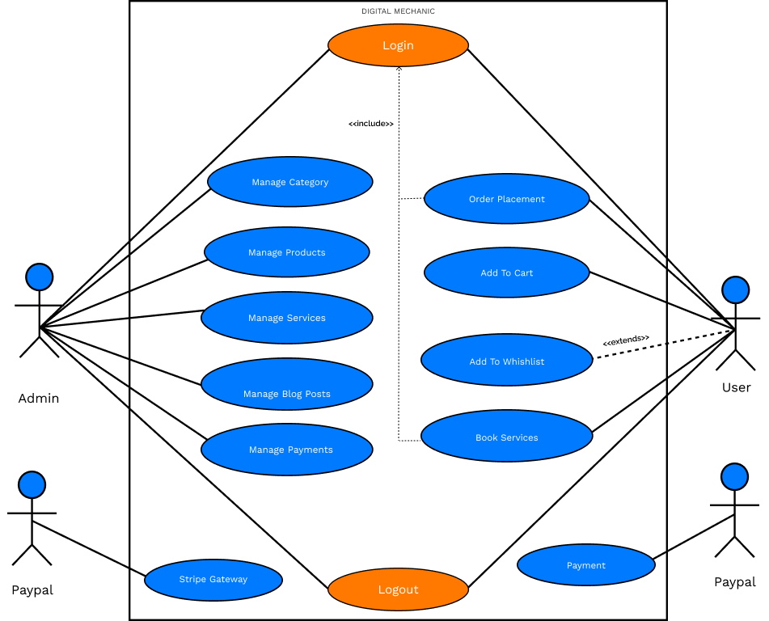

**3.3 Data Flow Diagram:**

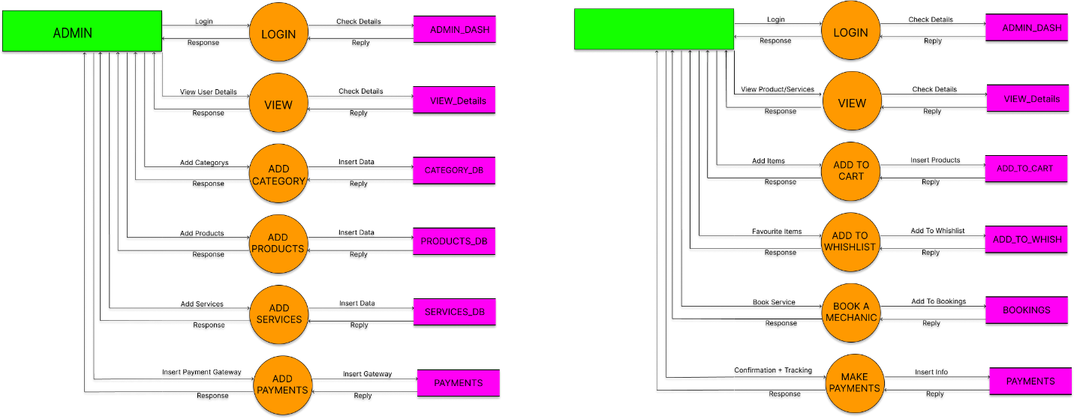

**3.4 Activity Diagram:**

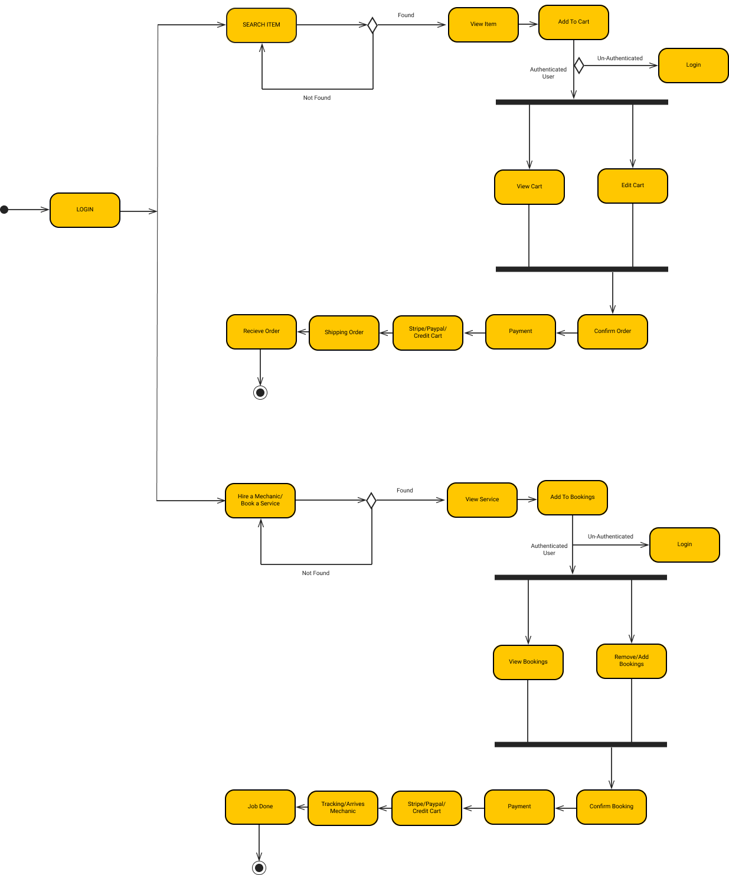

**3.5 Sequence Diagram:**

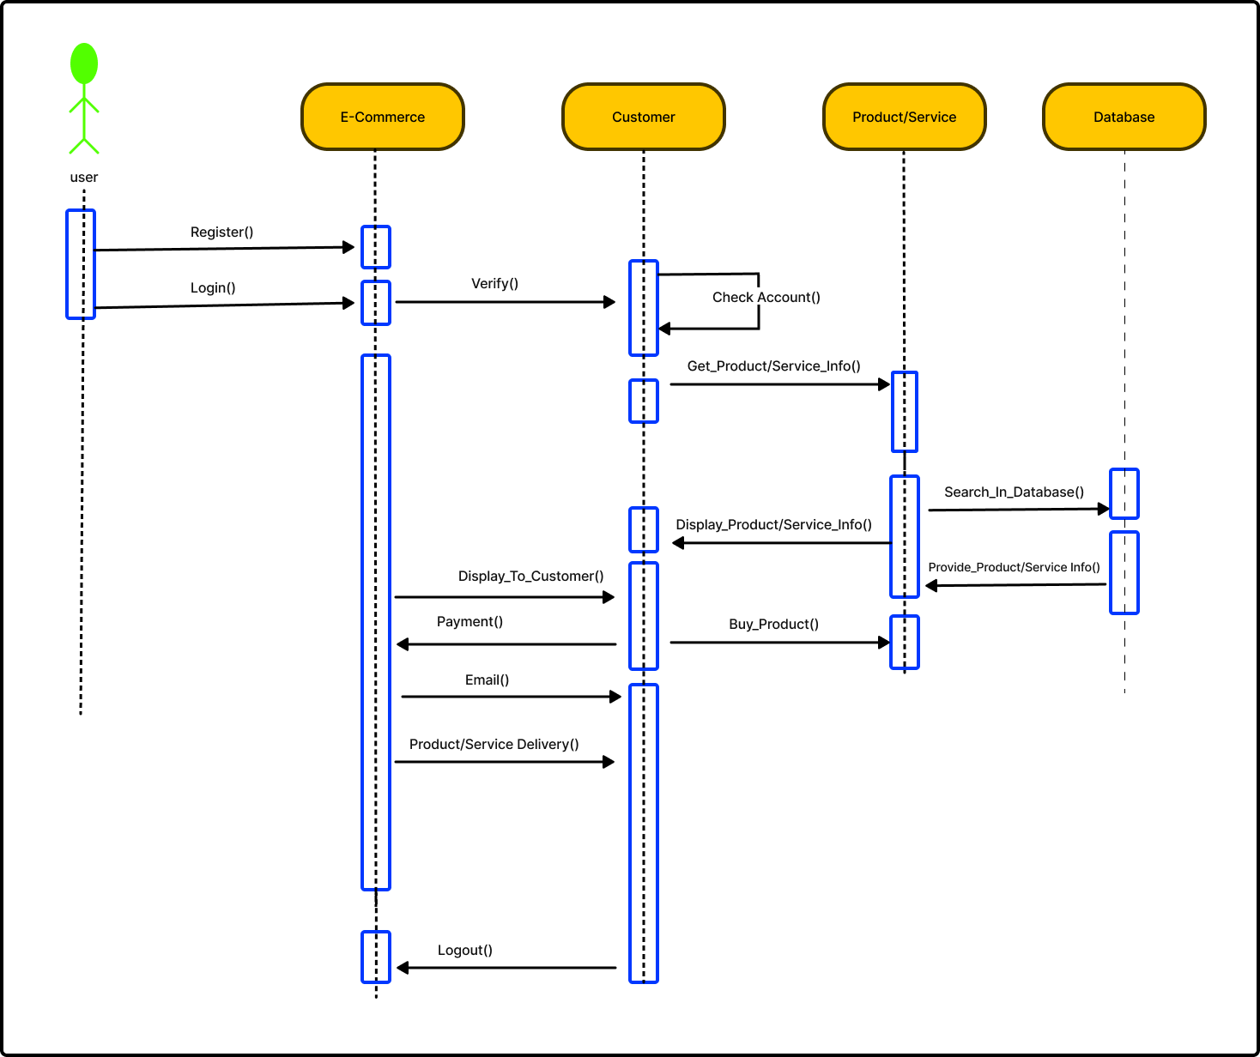

**3.6 Architecture Diagram:**

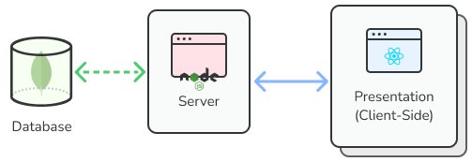

**3.7 Entity Relationship Diagram (ERD):**

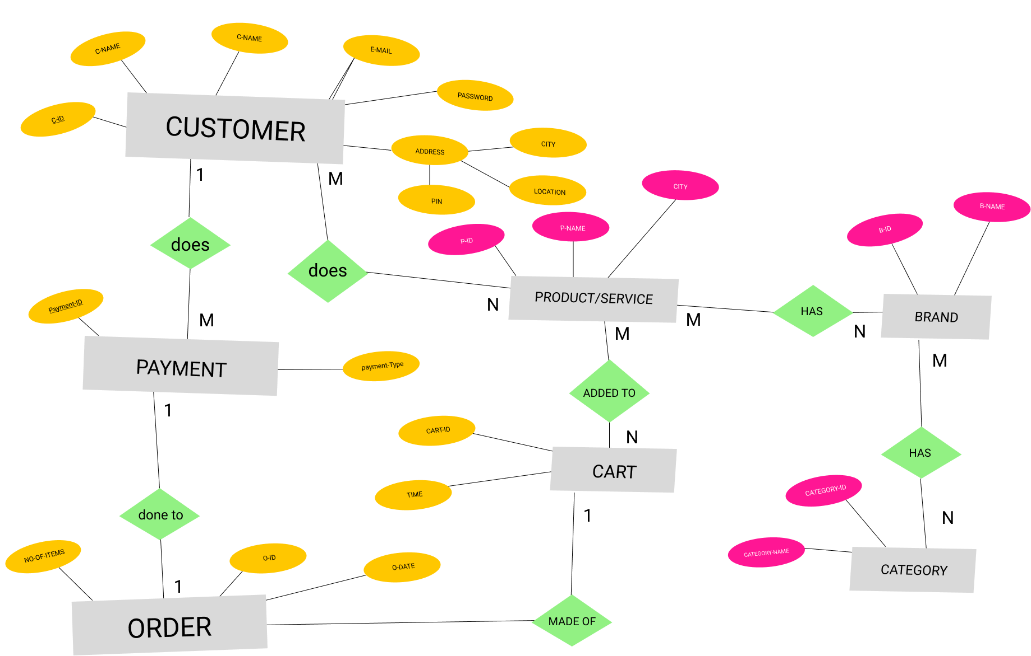

**CHAPTER 4: IMPLEMENTATION**

**4.1 System Implementation: -**

The implementation development platform for the digital mechanic system involves selecting a combination of tools and technologies based on the system requirements. The choice of appropriate programming languages is determined by the nature of the project. This chapter provides a clear explanation of the developed system and highlights the different modules that have been created using the selected tools and technologies. The system facilitates the connection between the application admin, users, and the customers. The digital mechanic system specifically includes the following modules. We have already discussed the module wise requirements but in this part I want to share the main modules that are admin and user/customer and their roles and requirements.

* **For User:**

1. User Registration/ User Log In

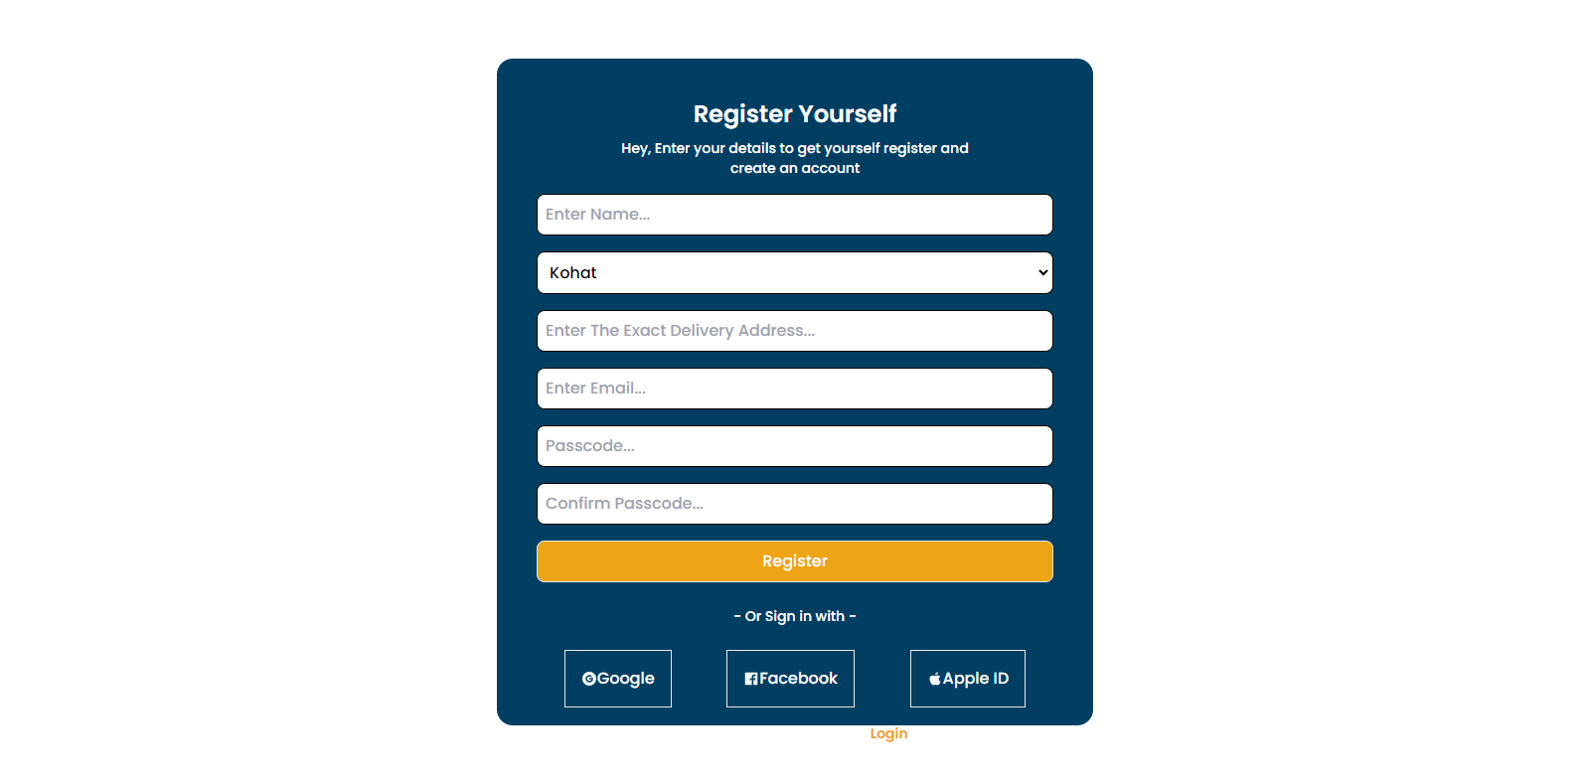

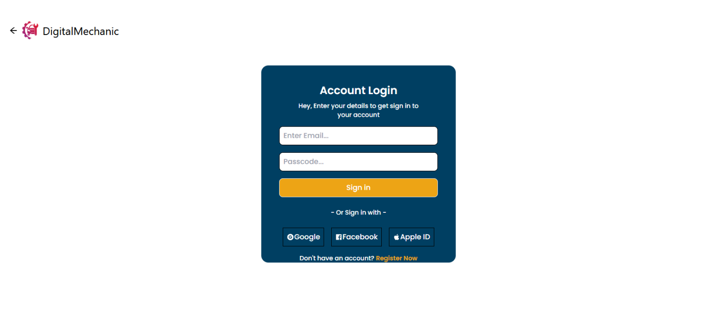

1. Home Page and Categories

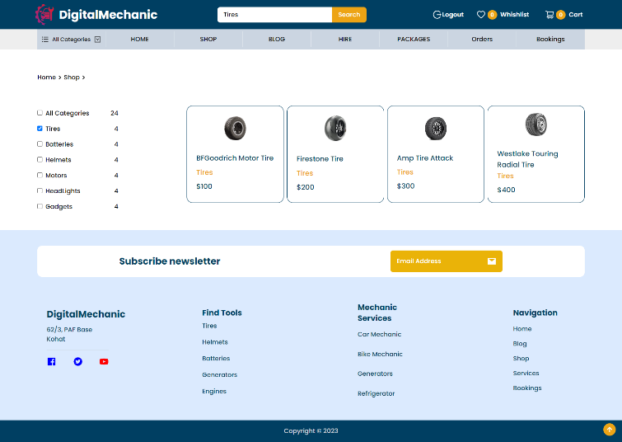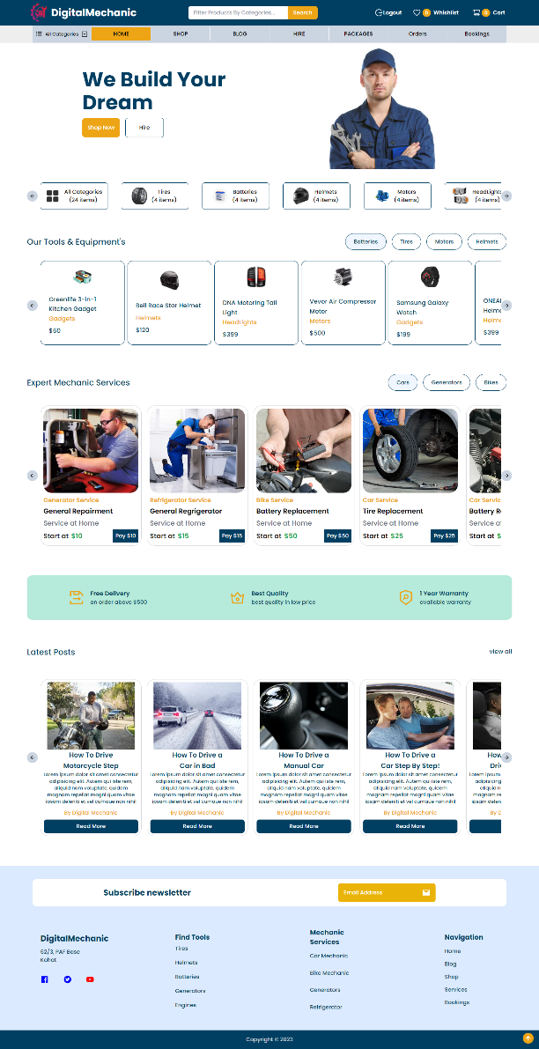

1. Check blogs, products and services

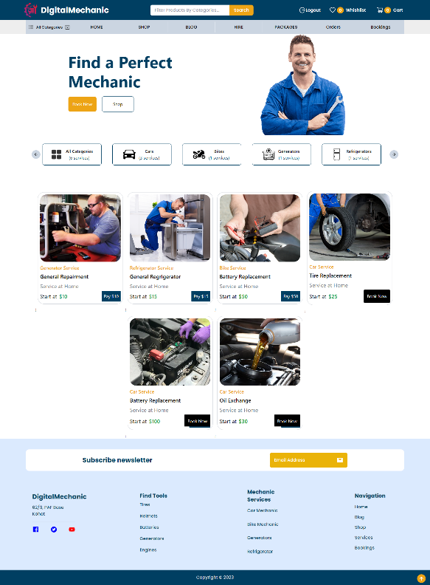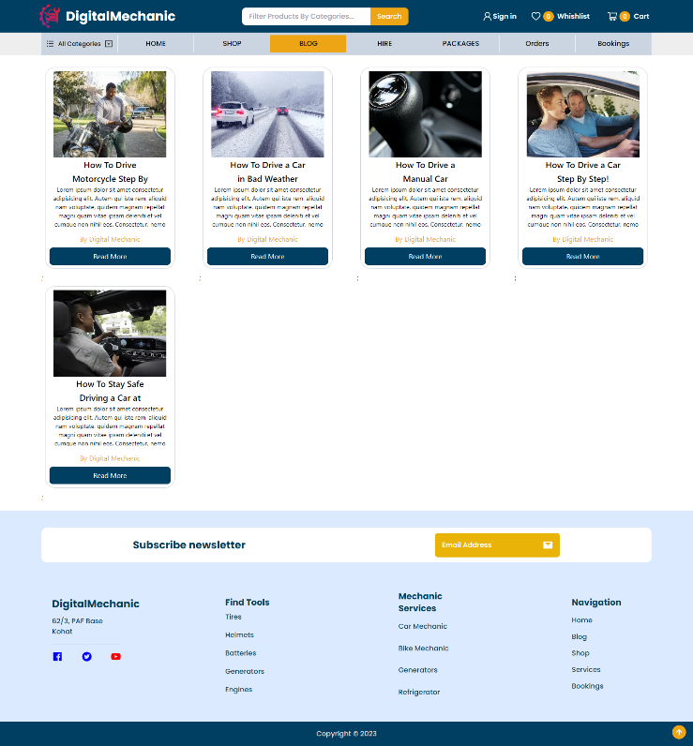

1. Visit the Shop page

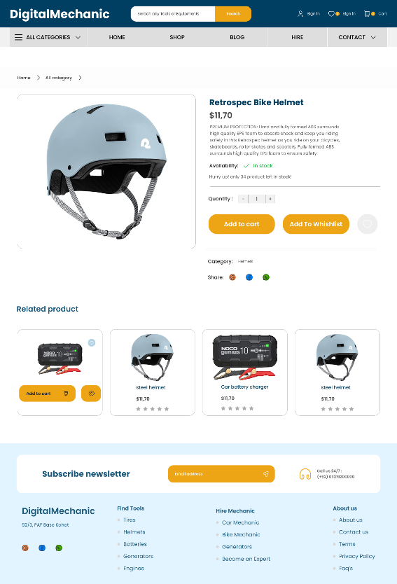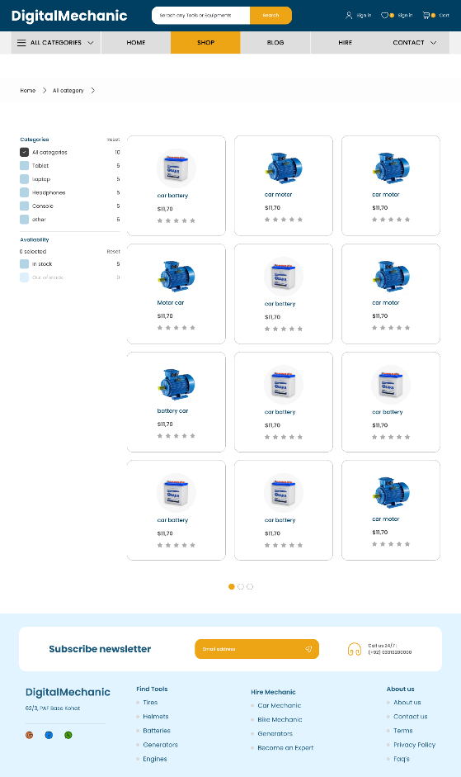

1. Add items to cart/Wishlist

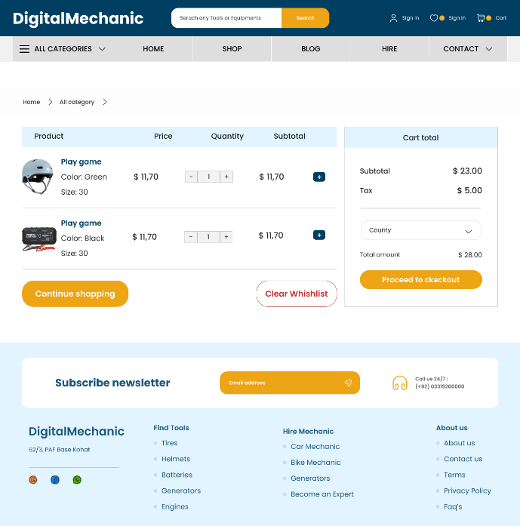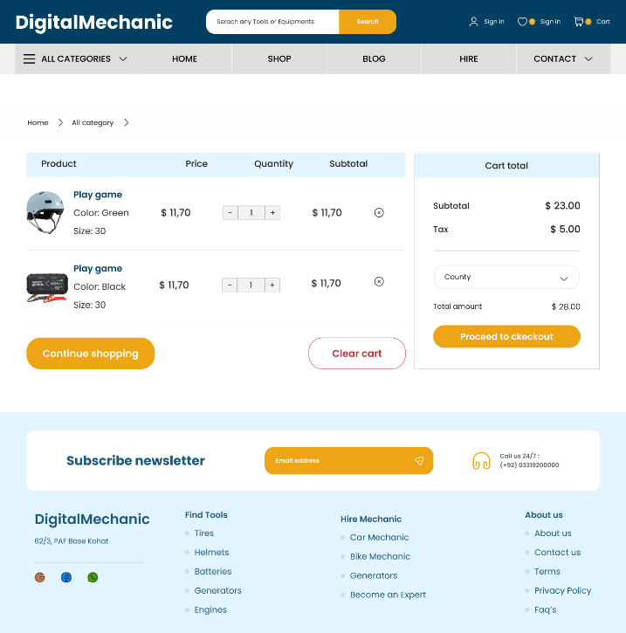

1. Book a service
2. Check your orders

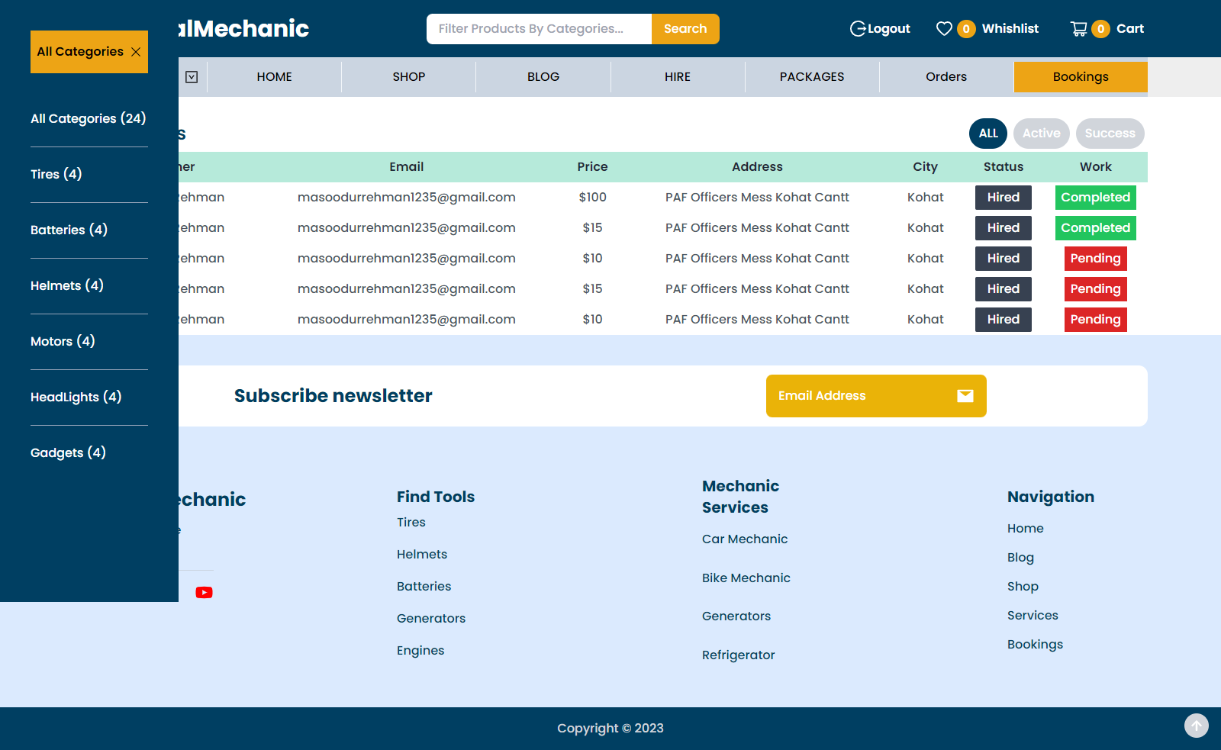

1. Check your bookings/services
2. Track your order
3. logout

* **For Admin:**

1. Admin Log In
2. Add and remove products

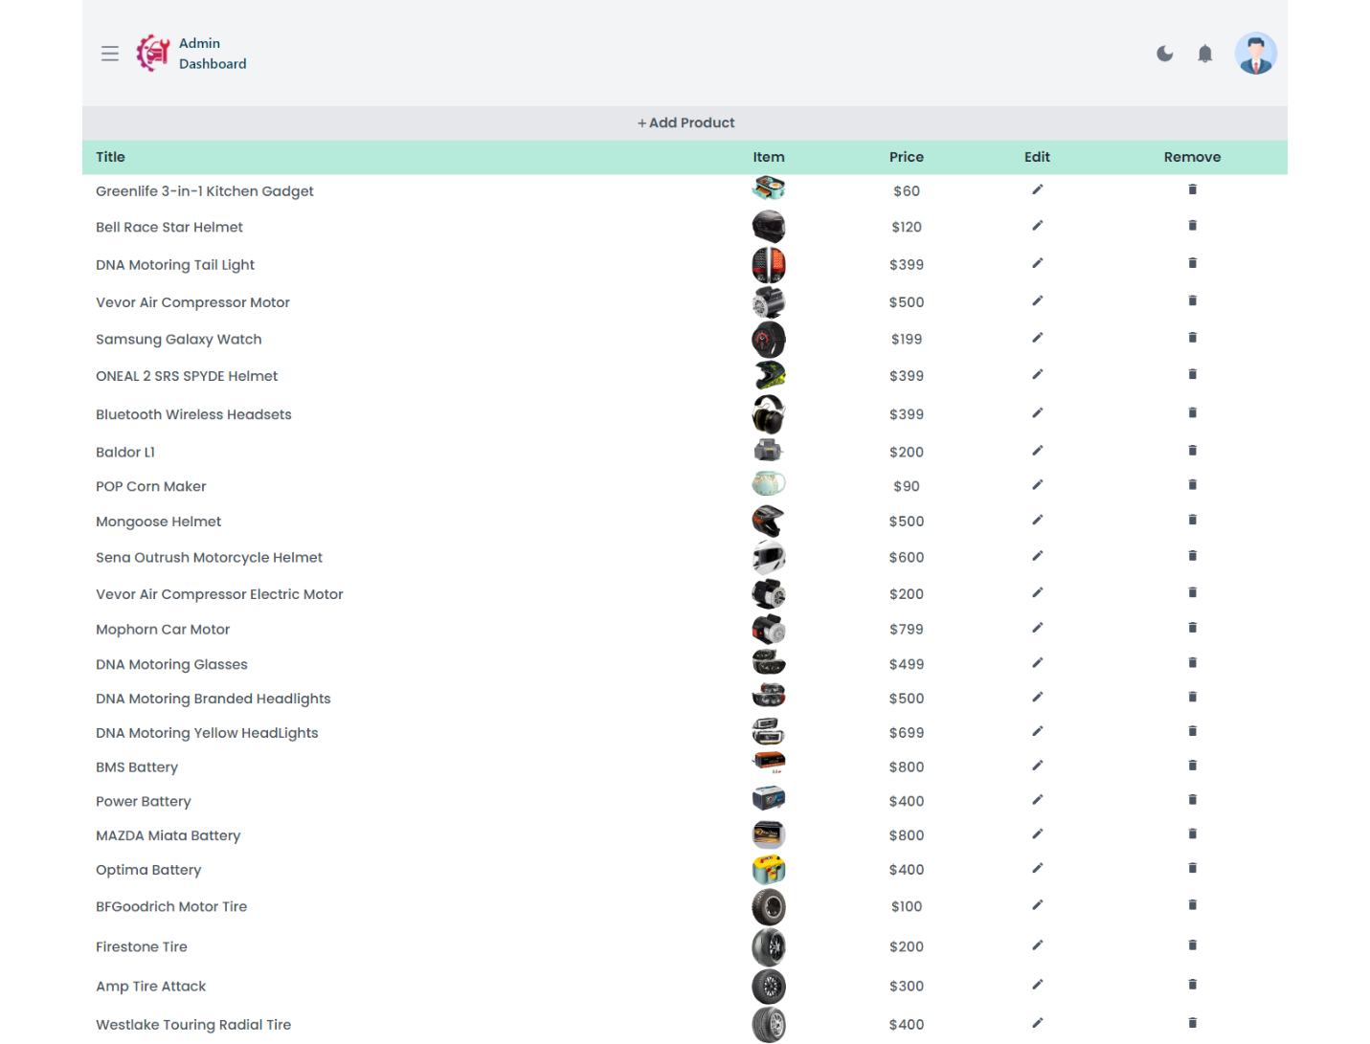

1. Add and remove blog posts
2. Add and remove services
3. Update the status of products

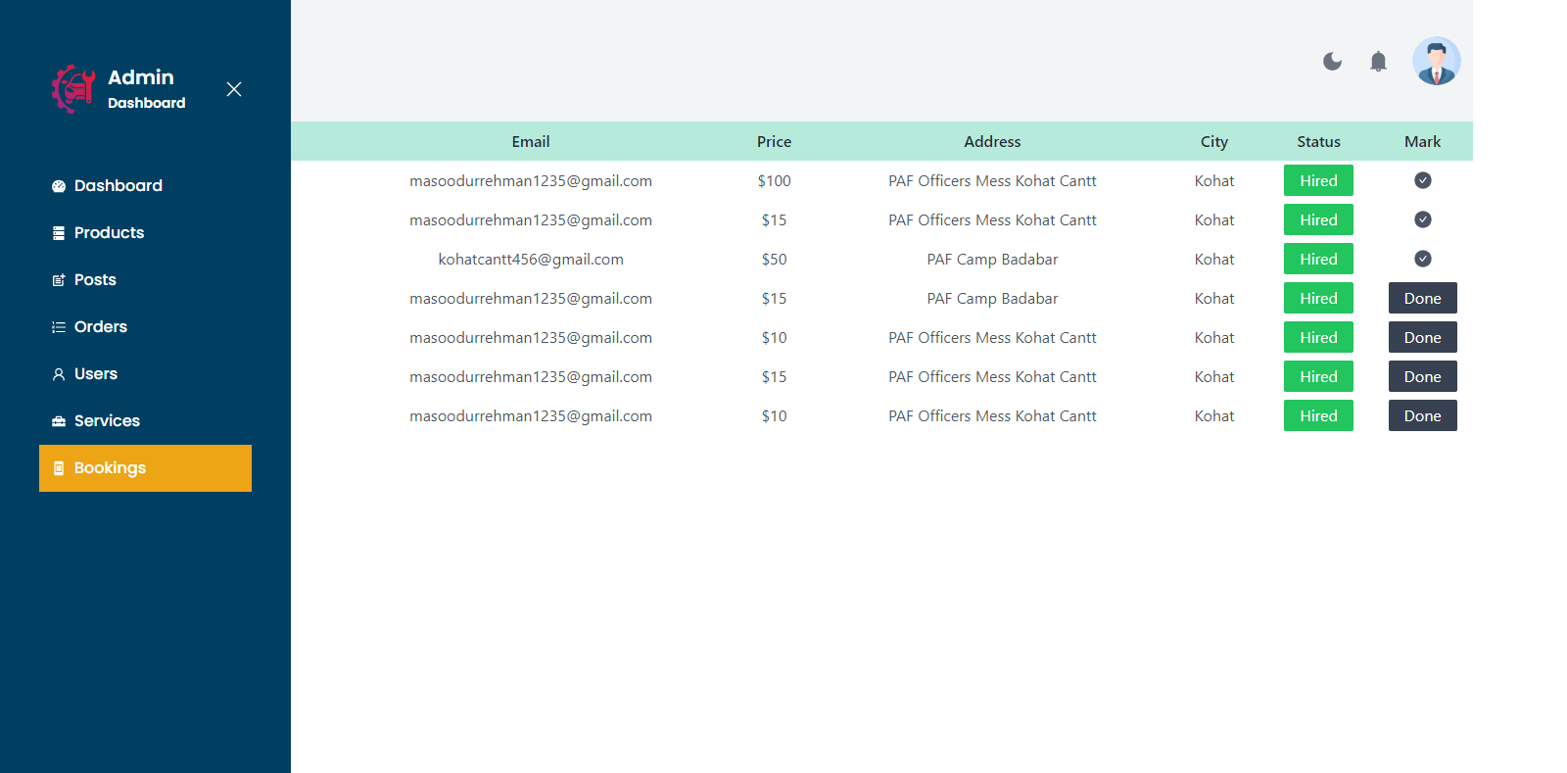

1. Update the status of bookings/services
2. Check users
3. Enable dark mode/Dashboard

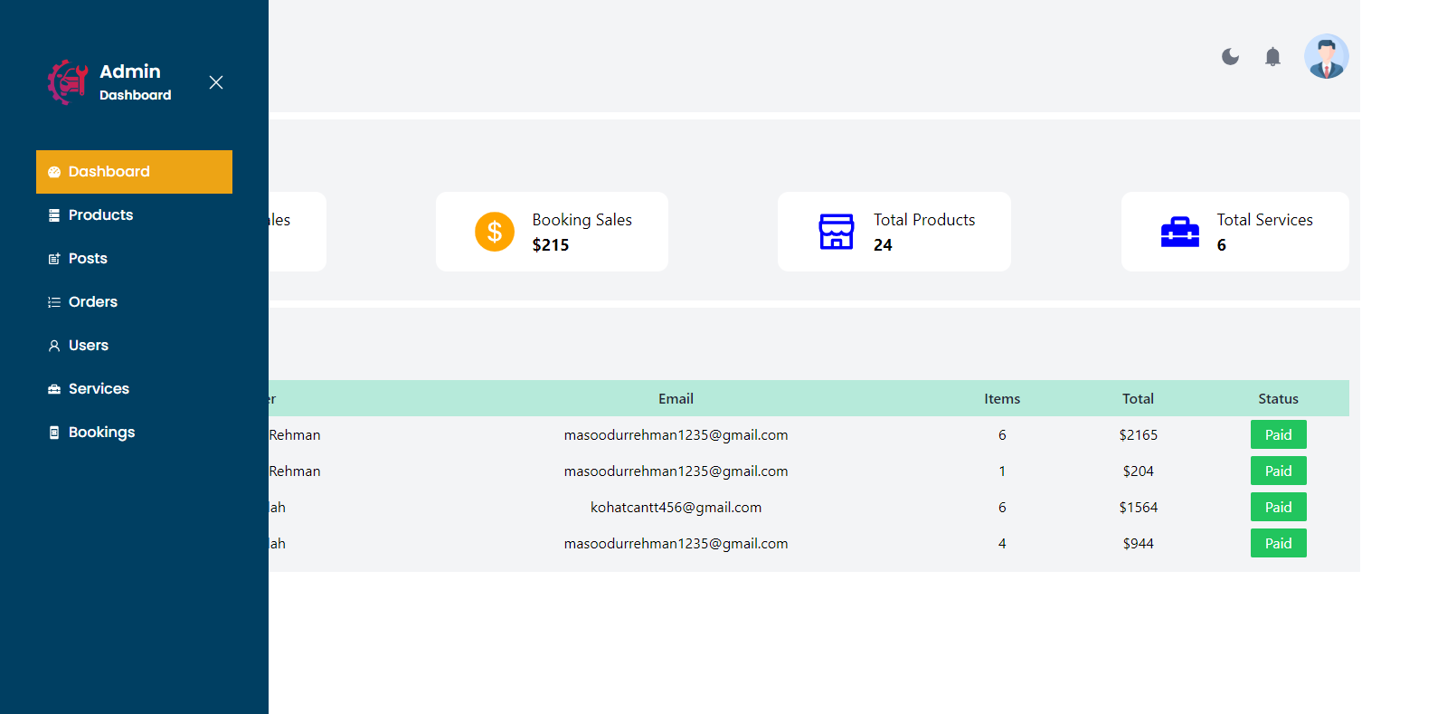

1. Logout

**Mobile App Screens**

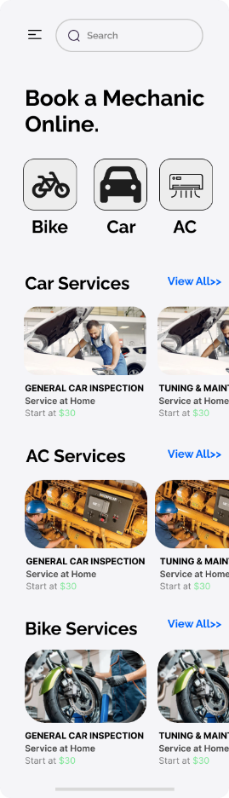

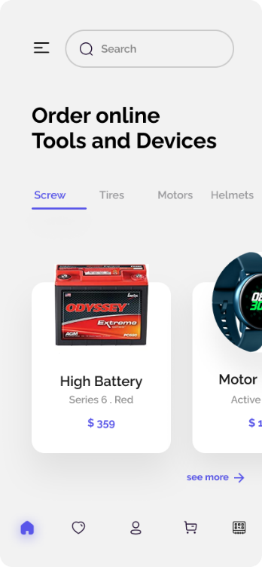 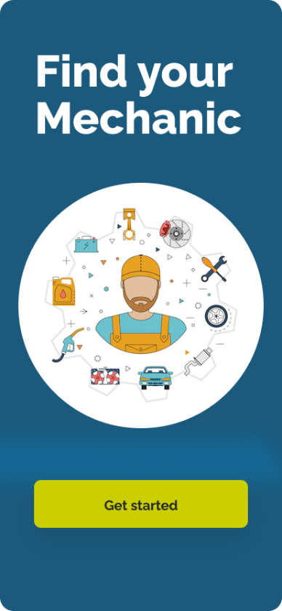 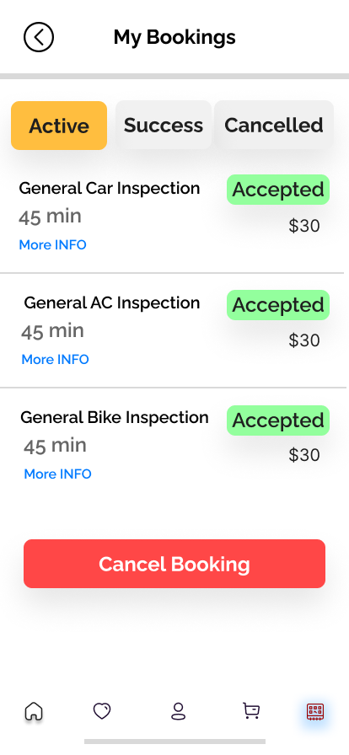

**4.2 Selection of Language: -**

The selection of a programming language is a critical decision in any software or web-based application development project. Whether you are creating a website or an Android application, choosing the right programming language is essential. To make an informed choice, it is important to assess the specific requirements of your project and identify the language that best suits those needs. Cost is another significant factor to consider during the language selection process. Making the wrong language choice can lead to financial losses for developers. For shorter projects or those with straightforward requirements, opting for a simple and easy-to-use language can be beneficial. Such a language enables developers to efficiently build the project within the designated timeframe.

Additionally, it should facilitate the enforcement of correct coding practices, support the target platform environments, and offer readily available debugging techniques. Furthermore, the selected language should support portability, allowing the application to run smoothly across different systems and platforms. It is crucial for the language to align with the purpose of the project, ensuring that it can effectively handle the required functionalities and meet the desired objectives. By carefully considering these factors, including project requirements, cost implications, simplicity, enforcement of correct coding practices, platform support, debugging capabilities, portability, and fitness for purpose, developers can make an informed decision regarding the most suitable programming language for their software or web-based application.

|  |  |
| --- | --- |
| Programming Language | JavaScript |
| Front End Library | React/React Native |
| Back End Language | Node.js/Express |
| Database | Mongodb |

**CHAPTER 5: TESTING, INTEGRATION AND EVALUATION**

**5.1 System Testing**

Entire system is tested as per the requirements. Black-box type testing that is based on overall requirements specifications, covers all combined parts of a system

**5.2 Acceptance Testing**

Normally this type of testing is done to verify if system meets the customer specified requirements. User or customer does this testing to determine whether to accept application

**Table 5.3 –** Unit Testing: Sign up page for Users

*Objective:* To ensure the sign-up form is working correctly.

|  |  |  |  |  |
| --- | --- | --- | --- | --- |
| no | Test case/test script | Attribute and value | Expected result | result |
| 1 | Verify user sign up page is working after click on the „sign up‟ button on sign up page with correct input data  ENTER FULL NAME  ENTER EMAIL  ENTER PASSWORD  CITY | FULL NAME:  Masood Ur Rehman  CITY: Kohat  EMAIL: masoodurrehman1235@gmail.com PASSWORD: chitral | Successfully account created and comes to login page of the Digital Mechanic Website | pass |
| 2 | Verify user is not sign up after click on “signup‟ button on signup page with null values | EMAIL: masoodurrehman1235@gmail.com  PASSOWRD: NOT ENTERED  FULL NAME: Masood Ur Rehman  CITY: NOT CHOOSEN | Signup failed, error  massage shown and  request user to fill the form again | PASS |
| 3 | Verify user sign up after click on “signup‟ button on signup page with invalid email | EMAIL:  abdullah@gmail.com | Signup failed, error  massage shown as email already exists | PASS |

**Table 5.4 –** Unit Testing: Home Page for Users

*Objective:* To ensure the Home Page is working correctly.

|  |  |  |  |  |
| --- | --- | --- | --- | --- |
| no | Test case/test script | Attribute and value | Expected result | result |
| 1 | Verify Home Page is working properly by getting products. | Products | Successfully getting all products | pass |
| 2 | Verify Home Page is working properly by getting services. | Services | Successfully getting all services | PASS |
| 3 | Verify Home Page is working properly by getting blog posts. | Blog posts | Successfully getting all blog posts | PASS |

**Table 5.5 –** Unit Testing: Orders page for Users

*Objective:* To ensure the orders page for users is working correctly.

|  |  |  |  |  |
| --- | --- | --- | --- | --- |
| no | Test case/test script | Attribute and value | Expected result | result |
| 1 | Verify that orders are fetching correctly from the backend. | All tab with mixed order status | Successfully shows mixed pending and completed orders to customer. | pass |
| 2 | Verify that on clicking the active button it only shows the pending orders | Active tab with only pending order status | Successfully shows pending orders to customer. | PASS |
| 3 | Verify that on clicking the completed button it shows the completed orders only | Completed tab with completed order status | Successfully shows completed orders to customer. | PASS |

**Table 5.6 –** Unit Testing: Bookings page for Admin

*Objective:* To ensure the Bookings Page for admin is working correctly.

|  |  |  |  |  |
| --- | --- | --- | --- | --- |
| no | Test case/test script | Attribute and value | Expected result | result |
| 1 | Verify that admin gets booking list made by users | Booking made by user | Successfully gets | pass |
| 2 | Verify that on clicking the done button the service/booking is completed | Update booking status | Successfully update booking status | PASS |
| 3 | Verify that customer is shown completed status for their booking. | Booking status for customers is updated or not | Successfully updated on client side booking as well. | PASS |

**CHAPTER 6: CONCLUSION AND FUTURE WORK**

**Conclusion:**

The Digital Mechanic FYP project is an online web and mobile based application, designed to support the people for booking mechanic services as well as for buying tools and equipment’s for themselves at the convenience of their door step. This application aims to address the main challenges faced by the community in the manual mechanic system and shopping. Through this project, we have made significant progress in solving these issues and providing a more efficient platform in the form of Digital Mechanic.

**Future Work:**

While we have successfully tackled the fundamental problems in this application, our plan is to continue working on this project in the future and enhance its effectiveness by introducing advanced modules. Currently, the application allows customers to register and receive notifications for their orders via email. In the future, we aim to incorporate a native mobile notification option that enables people to get notification on their phone easily. Plus, I am also focused in advancing my mobile application. Due to less time the mobile application is having less features compared to website. This will help ensure the customer to build trust and make our platform even better to provide quality services.

**References:**

1. Gallup Pakistan, Pakistan Economic Survey 2020-21, <https://www.finance.gov.pk/survey_2021.html>
2. [Katherine Darsie](https://blog.rocketlevel.com/author/katherine-darsie), Top 6 Reasons Auto Repair Shops Need a website, [https://blog.rocketlevel.com/top-6-reasons-why-auto-repair-shop](https://blog.rocketlevel.com/top-6-reasons-why-auto-repair-shops-need-a-website)
3. <https://www.mechanicustaad.pk>
4. <https://www.careem.com/>